**SKIN DISEASE DETECTION AND CLASSIFICATION USING DEEP LEARNING CNN**

**INTRODUCTION**

* 1. **project overview**

Malignant melanoma is the leading cause of death from diseases of skin .Malignant melanoma is considered to be the most dangerous form of skin cancer. This type of skin cancer occurs when the human skin is exposed to the ultraviolet radiation (UV) emitted from sunshine or tanning beds, which caused the damage to skin cells. Image-based computer aided diagnosis systems have significant potential for screening and early detection of malignant melanoma. In this paper, we propose a new skin melanoma CAD system using texture analysis methods. The proposed CAD system consists of four steps: hair removal, filtering, feature extraction and classification. Before working on the image we should remove hair from it to facilitate infected part detection. In the feature extraction step a histogram of oriented gradients (HOG) used to extract features, Our CAD system classifies between non-melanoma skin lesions (represented as common nevi or dysplastic nevi) and melanoma. The experimental results show that extracting HOG features after hair removal yields the best classification results. python software is used for skin cancer detection. Machine learning based model is implemented for detect and classify the skin disease detection and classification ,flask based design is provide the user interface provide the result

* 1. **purpose**

The purpose of the project is design and implementation of deep learning model deployed for detection of image processing based skin disease

**2. LITEATURE SURVEY**

**LITERATURE SURVEY**

**TITLE:** Skin cancer and new treatment perspectives: A review.

**AUTHOR:** Simes, M. C. F., J. J. S. Sousa, and A. A. C. C. Pais.

**YEAR: 2015**

**DESCRIPTION:** [Skin cancers](https://www.sciencedirect.com/topics/medicine-and-dentistry/skin-cancer) are by far the most common malignancy of humans, particularly in the [white population](https://www.sciencedirect.com/topics/medicine-and-dentistry/white-population). The growing incidence of cutaneous malignancies has heralded the need for multiple treatment options. Although surgical modalities remain the mainstay of treatment, new research and fresh innovation are still required to reduce [morbidity](https://www.sciencedirect.com/topics/medicine-and-dentistry/morbidity) and mortality. Approaches for skin cancer may pass through new technological methods instead of new molecules. The first part of this paper provides a review of the state of the art regarding skin cancer disease as well as epidemiology data. Then, it describes the gold standards of the current recommended therapies worldwide and the actual needs of these patients. This is the first paper that highlights the novel and future therapeutic perspectives for the treatment of skin malignancies, new [therapeutic agents](https://www.sciencedirect.com/topics/medicine-and-dentistry/therapeutic-agent) and promising technological approaches, from nanotechnology to immunotherapy.

**TITLE:** A benchmark for automatic visual classification of clinical skin disease images.

**AUTHOR:** Sun, Xiaoxiao.

**YEAR: 2016**

**DESCRIPTION** Skin disease is one of the most common human illnesses. It pervades all cultures, occurs at all ages, and affects between 30 % and 70 % of individuals, with even higher rates in at-risk. However, diagnosis of skin diseases by observing is a very difficult job for both doctors and patients, where an intelligent system can be helpful. In this paper, we mainly introduce a benchmark dataset for clinical skin diseases to address this problem. To the best of our knowledge, this dataset is currently the largest for visual recognition of skin diseases. It contains 6,584 images from 198 classes, varying according to scale, color, shape and structure. We hope that this benchmark dataset will encourage further research on visual skin disease classification. Moreover, the recent successes of many computer vision related tasks are due to the adoption of Convolutional Neural Networks (CNNs), we also perform extensive analyses on this dataset using the state of the art methods including CNNs.

**TITLE:** Improving the diagnostic accuracy of dysplastic and melanoma lesions using the decision template combination method.

**AUTHOR:** Faal, Maryam,

**YEAR: 2013**

**DESCRIPTION:** Melanoma is the most dangerous type of skin cancer, and early detection of suspicious lesions can decrease the mortality rate of this cancer. In this article, we present a multi‐classifier system for improving the diagnostic accuracy of melanoma and dysplastic lesions based on the decision template combination rule.First, the lesion is differentiated from the surrounding healthy skin in an image. Next, shape, colour and texture features are extracted from the lesion image. Different subsets of these features are fed to three different classifiers: k‐nearest neighbour (k‐NN), support vector machine (SVM) and linear discriminant analysis (LDA). The decision template method is used to combine the outputs of these classifiers.

**TITLE:** Automatic classification of skin lesions using color mathematical morphology-based texture descriptors.”

**AUTHOR:** Gonzalez-Castro, Victor,

**YEAR: 2015**

**DESCRIPTION:** In this paper an automatic classification method of skin lesions from dermoscopic images is proposed. This method is based on color texture analysis based both on color mathematical morphology and Kohonen Self-Organizing Maps (SOM), and it does not need any previous segmentation process. More concretely, mathematical morphology is used to compute a local descriptor for each pixel of the image, while the SOM is used to cluster them and, thus, create the texture descriptor of the global image. Two approaches are proposed, depending on whether the pixel descriptor is computed using classical (i.e. spatially invariant) or adaptive (i.e. spatially variant) mathematical morphology by means of the Color Adaptive Neighborhoods (CANs) framework. Both approaches obtained similar areas under the ROC curve (AUC): 0.854 and 0.859 outperforming the AUC built upon dermatologists' predictions (0.792).

**TITLE:** Performance Analysis of GFE, HOG and LBP Feature Extraction Techniques using kNN Classifier for Oral Cancer Detection.

**AUTHOR:** Stella, X. Arockia, TamilNadu Sivagangai, and India Dr N. Sujatha.

**YEAR: 2016**

**DESCRIPTION:** Oral cancer is the abnormal growth of suspicious tissues in the mouth and vocal region that consumes the life of both males and females at a high rate. Early diagnosis of oral cancer makes the treatments successful. The advancements in medical image processing greatly helps in the detection of oral cancer. The diagnosis is commonly done in accordance with the morphology and features of the images. The commonly used feature extraction techniques failed to produce high accuracy and resulted in high false positive rates. As the extracted features are the base for classifying the severity, the classification techniques also resulted in low classification accuracy. In order to resolve these issues, this paper proposes an oral cancer detection system. The median filtering technique is used in the proposed system for preprocessing. In order to get the essential characteristics of features, watershed segmentation is applied before feature extraction. The feature extraction is carried out by the following techniques: Gamma based Feature Extraction (GFE), Histogram of Oriented Gradients (HOG) and Local Binary Pattern (LBP). Finally, the extracted features are fed into the kNN classifier for the efficient detection of oral cancer. This paper discusses the comparative analysis of HOG, LBP and GFE techniques. The experimental results are evaluated in terms of accuracy, sensitivity, specificity and Positive Predictive Value (PPV).

**EXISTING SYSTEM PROBLEM**

**EXISTING SYSTEM**

The color of patient skin helps doctors to determinate the type of skin lesion, if the skin lesion is diagnosed as melanoma, its color could be black, brown, pink, red, purple, blue or white,. The dermoscopy technique is high spread skin imaging way that helps in skin lesion detection. a dermatoscope device take an image, known as dermoscopic image, with a low level noise to examine the skin lesion by magnifying and filtering the infected part of skin . Another aiding way to detect the skin lesion at an early stage is the computer aided diagnosis (CAD) system. The dermoscopic images of skin lesions have been classified by Gonzalez-Castro et al. Global andlocal feature extraction method to extract a different features of an image such as color, texture, shape and domain specific features.

**EXISTING SYSTEM DRAWBACKS**

* The conventional methods failed to give the desired result.
* No standard evolution of previous classifiers (limited data on Sensitivity & specificity).
* Less effective feature extraction methods used in existing systems.
  1. **references**

**1.** Kachuee, Mohammad, Shayan Fazeli, and Majid Sarrafzadeh. "Ecg heartbeat classification: A deep transferable representation." 2018 IEEE international conference on healthcare informatics (ICHI). IEEE, 2018

2.S. Zhang, W. Wang, J. Ford, and F. Makedon, “Learning from incomplete ratings using non-negative matrix factorization,” in Proc. 6th SIAM Int. Conf. Data Mining, 2006, pp. 549–553.

3.T. Hofmann and J. Puzicha, “Latent class models for collaborative filtering,” in Proc. 6th Int. Joint Conf. Artif. Intell., 1999, pp. 688–693.

4.B. M. Sarwar, G. Karypis, J. A. Konstan, and J. Reidl, “Item-based collaborative filtering recommendation algorithms,” in Proc. 10th Int. World Wide Web Conf., 2001, pp. 285–295

5.T. George and S. Merugu, “A scalable collaborative filtering framework based on co-clustering,” in Proc. 5th IEEE Int. Conf. Data Mining, 2005, pp. 625–628

* 1. **problem statement definition**
* Cardiologists by using various values which occurred during the ECG recording can decide whether the heart beat is normal or not. Since observation of these values are not always clear, existence of automatic ECG detection system is required
* Luz, Eduardo José da S., et al. "ECG-based heartbeat classification for arrhythmia detection: A survey." Computer methods and programs in biomedicine 127 (2016): 144-164
* Romdhane, Taissir Fekih, and Mohamed Atri Pr. "Electrocardiogram heartbeat classification based on a deep convolutional neural network and focal loss." Computers in Biology and Medicine 123 (2020): 103866

**3.ideation and proposed solution**

**3.1 empathy map canvas**

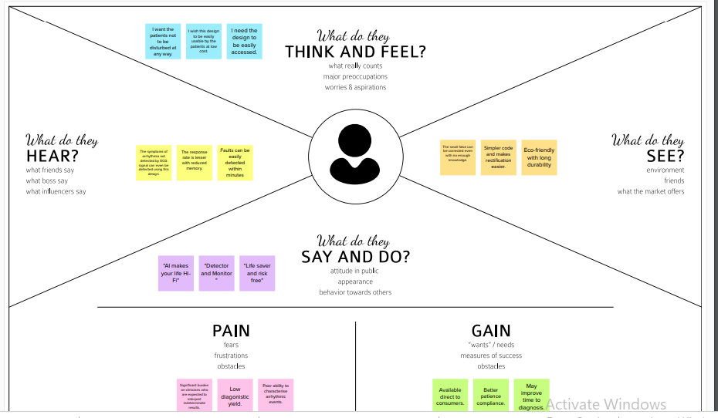

**3.2 ideation and brain storming**

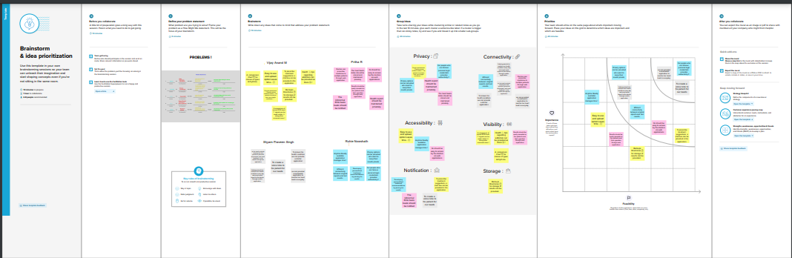

**3.3 proposed solutions**

Deep learning based algorithm is implemented using for train the image using deep learning model In this paper, we propose a new melanoma CAD system. Removing hair from skin lesion dermoscopic images will be the first step to apply, then using median filter with a suitable dimensions will be the next step to do, histogram of oriented gradients (HOG), will be using to extract special features from the images. The final step will be classification using a Support Vector Machines (SVM) classifier to determine the skin lesion. The output layer of SVM has two neural nodes, related to the number of neural nodes that classify between positive (abnormal) and negative (normal) cases. Where positive cases refer to melanoma skin lesion and negative cases refer to common nevi or dysplastic nevi (non-melanoma). The final results evaluate the classifier performance by calculating some metrics such as AUC and sensitivity.

**DATASETSs**

The HAM10000 (Human Against Machine with 10, 000 training images) dataset released by Tschandl et. al. includes dermoscopy images from diverse populations acquired and stored by different modalities [66]. The dataset is publicly available through the ISIC archive and consists of 10, 015 dermoscopy images, which are utilized as a training set for testing machine learning algorithms. Cases include a representative collection of all important diagnostic categories in the realm of pigmented lesions. The diagnoses of all melanomas were verified through histopathological evaluation of biopsies, while the diagnoses of nevi were made by either histopathological examination (24%), expert consensus (54%) or another diagnosis method, such as a series of images that showed no temporal changes (22%).

**Design and implementation**

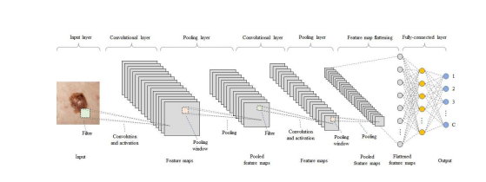

TensorFlow was developed by researchers and engineers from the Google Brain team. It is by far the most popular software library in the field of deep learning (though others are catching up quickly). One of the biggest reasons accounting for the popularity of TensorFlow is that it supports multiple programming languages, such as Python, C++ and R, to build deep learning models. It is handy for creating and experimenting with deep learning architectures. In addition, its formulation is convenient for data (such as inputting graphs, SQL tables, and images) integration. Moreover, it provides proper documentations and walkthroughs for guidance. The flexible architecture of TensorFlow makes it easy for people to run their deep learning models on one or more CPUs and GPUs. It is backed by Google, which guarantees that it will stay around for a while. Therefore, it makes sense to invest time and resources to use it.

**3.4 problem solution fit**

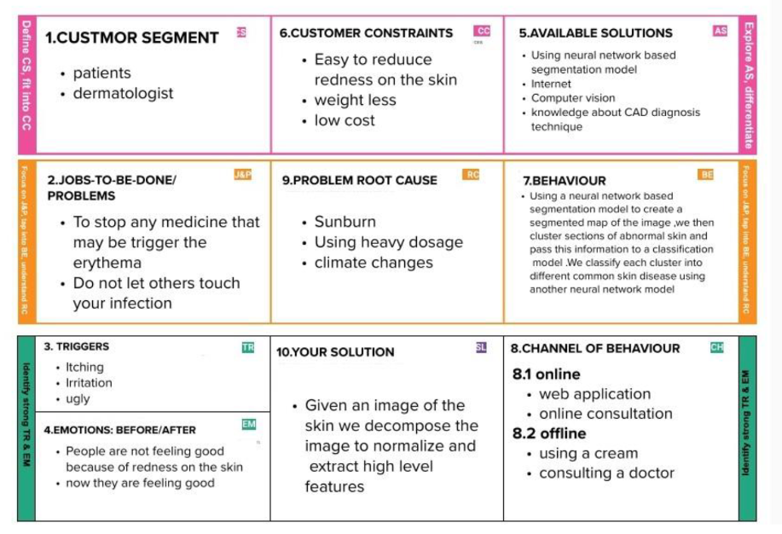

**4.requirement analysis**

**4.1 functional requirement**

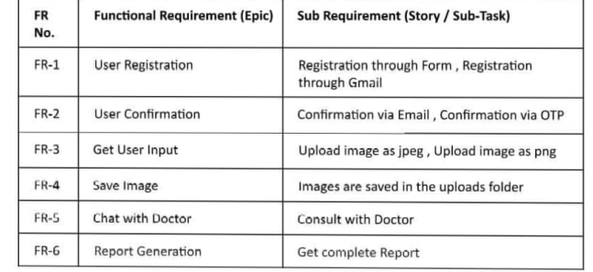

**4.2 Non -functional requirement**

A Data Flow Diagram (DFD) is a traditional visual representation of the information flows within a system. A neat and clear DFD can depict the right amount of the system requirement graphically. It shows how data enters and leaves the system, what changes the information, and where data is stored.

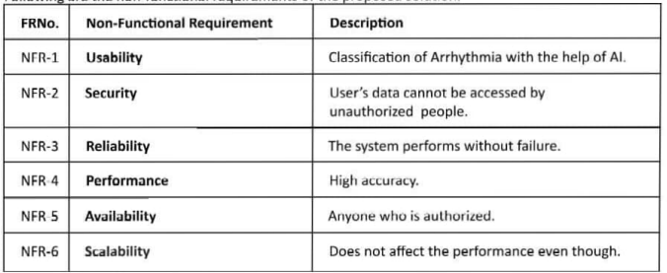

**5.project design**

**5.1 Data flow diagrams**

Data set image skin images

Loading of image

Preprocessing of image

Train the mode

CNN layers training

Feature extraction with model training

Model deployment

Testing image

**5.2 solutions and Technical Architecture**

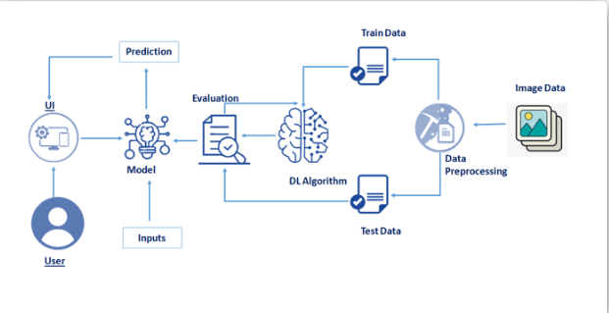

**6.Project planning and scheduling**

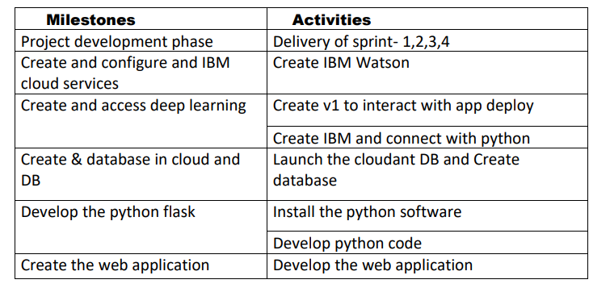

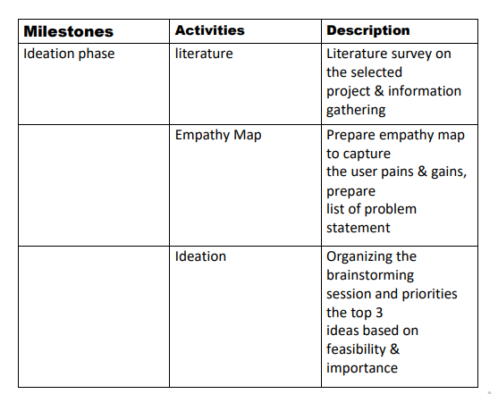

**7.coding**

**%packages**

import os

%matplotlib inline

import matplotlib.pyplot as plt

import numpy as np

import pandas as pd

import os

from glob import glob

import seaborn as sns

from PIL import Image

np.random.seed(11) *# It's my lucky number*

from sklearn.preprocessing import StandardScaler

from sklearn.model_selection import train_test_split, KFold, cross_val_score, GridSearchCV

from sklearn.metrics import accuracy_score

import itertools

import keras

from keras.utils.np_utils import to_categorical *# used for converting labels to one-hot-encoding*

from keras.models import Sequential, Model

from keras.layers import Dense, Dropout, Flatten, Conv2D, MaxPool2D

from keras import backend as K

from keras.layers.normalization import BatchNormalization

from keras.utils.np_utils import to_categorical *# convert to one-hot-encoding*

from keras.optimizers import Adam, RMSprop

from keras.preprocessing.image import ImageDataGenerator

from keras.callbacks import ReduceLROnPlateau

from keras.wrappers.scikit_learn import KerasClassifier

from keras.applications.resnet50 import ResNet50

from keras import backend as K

**preprocessing of code**

size=64

color_mode='grayscale'

batch_size=32

train_images = train_generator.flow_from_dataframe(

    dataframe=dataframe_train,

    x_col='Filepath',

    y_col='Label',

    target_size=(size, size),

    color_mode=color_mode,

    class_mode='categorical',

    batch_size=batch_size,

    shuffle=True,

    seed=42,

    subset='training'

)

val_images = train_generator.flow_from_dataframe(

    dataframe=dataframe_train,

    x_col='Filepath',

    y_col='Label',

    target_size=(size, size),

    color_mode=color_mode,

    class_mode='categorical',

    batch_size=batch_size,

    shuffle=True,

    seed=42,

    subset='validation'

)

test_images = test_generator.flow_from_dataframe(

    dataframe=dataframe_test,

    x_col='Filepath',

    y_col='Label',

    target_size=(size, size),

    color_mode=color_mode,

    class_mode='categorical',

    batch_size=batch_size,

    shuffle=False

)

**Model summary**

# **es and making Dictionary of images and labels**

In this step I load in the pictures and turn them into numpy arrays using their RGB values. As the pictures have already been resized to 224x224, there's no need to resize them. As the pictures do not have any labels, these need to be created. Finally, the pictures are added together to a big training set and shuffeled.

In [2]:

linkcode

folder_benign_train = '../input/data/train/benign'

folder_malignant_train = '../input/data/train/malignant'

folder_benign_test = '../input/data/test/benign'

folder_malignant_test = '../input/data/test/malignant'

read = lambda imname: np.asarray(Image.open(imname).convert("RGB"))

*# Load in training pictures*

ims_benign = [read(os.path.join(folder_benign_train, filename)) for filename **in** os.listdir(folder_benign_train)]

X_benign = np.array(ims_benign, dtype='uint8')

ims_malignant = [read(os.path.join(folder_malignant_train, filename)) for filename **in** os.listdir(folder_malignant_train)]

X_malignant = np.array(ims_malignant, dtype='uint8')

*# Load in testing pictures*

ims_benign = [read(os.path.join(folder_benign_test, filename)) for filename **in** os.listdir(folder_benign_test)]

X_benign_test = np.array(ims_benign, dtype='uint8')

ims_malignant = [read(os.path.join(folder_malignant_test, filename)) for filename **in** os.listdir(folder_malignant_test)]

X_malignant_test = np.array(ims_malignant, dtype='uint8')

*# Create labels*

y_benign = np.zeros(X_benign.shape[0])

y_malignant = np.ones(X_malignant.shape[0])

y_benign_test = np.zeros(X_benign_test.shape[0])

y_malignant_test = np.ones(X_malignant_test.shape[0])

*# Merge data*

X_train = np.concatenate((X_benign, X_malignant), axis = 0)

y_train = np.concatenate((y_benign, y_malignant), axis = 0)

X_test = np.concatenate((X_benign_test, X_malignant_test), axis = 0)

y_test = np.concatenate((y_benign_test, y_malignant_test), axis = 0)

*# Shuffle data*

s = np.arange(X_train.shape[0])

np.random.shuffle(s)

X_train = X_train[s]

y_train = y_train[s]

s = np.arange(X_test.shape[0])

np.random.shuffle(s)

X_test = X_test[s]

y_test = y_test[s]

**Html coding**

<!DOCTYPE html>

<html lang="en">

<head>

<meta charset="UTF-8">

<meta name="viewport" content="width=device-width, initial-scale=1.0">

<meta http-equiv="X-UA-Compatible" content="ie=edge">

<title>Aroma Shop - Home</title>

<link rel="icon" href="static/img/Fevicon.png" type="image/png">

<link rel="stylesheet" href="static/vendors/bootstrap/bootstrap.min.css">

<link rel="stylesheet" href="static/vendors/fontawesome/css/all.min.css">

<link rel="stylesheet" href="static/vendors/themify-icons/themify-icons.css">

<link rel="stylesheet" href="static/vendors/nice-select/nice-select.css">

<link rel="stylesheet" href="static/vendors/owl-carousel/owl.theme.default.min.css">

<link rel="stylesheet" href="static/vendors/owl-carousel/owl.carousel.min.css">

<link rel="stylesheet" href="static/css/style.css">

</head>

<body>

<!--================ Start Header Menu Area =================-->

<header class="header_area">

<div class="main_menu">

<nav class="navbar navbar-expand-lg navbar-light">

<div class="container">

<a class="navbar-brand logo_h" href="index.html"><img src="static/img/logo.png" alt=""></a>

<button class="navbar-toggler" type="button" data-toggle="collapse" data-target="#navbarSupportedContent"

aria-controls="navbarSupportedContent" aria-expanded="false" aria-label="Toggle navigation">

<span class="icon-bar"></span>

<span class="icon-bar"></span>

<span class="icon-bar"></span>

</button>

<div class="collapse navbar-collapse offset" id="navbarSupportedContent">

<ul class="nav navbar-nav menu_nav ml-auto mr-auto">

<li class="nav-item active"><a class="nav-link" href="index.html">Home</a></li>

<li class="nav-item submenu dropdown">

<a href="#" class="nav-link dropdown-toggle" data-toggle="dropdown" role="button" aria-haspopup="true"

aria-expanded="false">Shop</a>

<ul class="dropdown-menu">

<li class="nav-item"><a class="nav-link" href="category.html">Shop Category</a></li>

<li class="nav-item"><a class="nav-link" href="single-product.html">Product Details</a></li>

<li class="nav-item"><a class="nav-link" href="checkout.html">Product Checkout</a></li>

<li class="nav-item"><a class="nav-link" href="confirmation.html">Confirmation</a></li>

<li class="nav-item"><a class="nav-link" href="cart.html">Shopping Cart</a></li>

</ul>

</li>

<li class="nav-item submenu dropdown">

<a href="#" class="nav-link dropdown-toggle" data-toggle="dropdown" role="button" aria-haspopup="true"

aria-expanded="false">Blog</a>

<ul class="dropdown-menu">

<li class="nav-item"><a class="nav-link" href="blog.html">Blog</a></li>

<li class="nav-item"><a class="nav-link" href="single-blog.html">Blog Details</a></li>

</ul>

</li>

<li class="nav-item submenu dropdown">

<a href="#" class="nav-link dropdown-toggle" data-toggle="dropdown" role="button" aria-haspopup="true"

aria-expanded="false">Pages</a>

<ul class="dropdown-menu">

<li class="nav-item"><a class="nav-link" href="sign.html">Login</a></li>

<li class="nav-item"><a class="nav-link" href="/register">Register</a></li>

<li class="nav-item"><a class="nav-link" href="tracking-order.html">Tracking</a></li>

</ul>

</li>

<li class="nav-item"><a class="nav-link" href="contact.html">Contact</a></li>

</ul>

<ul class="nav-shop">

<li class="nav-item"><button><i class="ti-search"></i></button></li>

<li class="nav-item"><button><i class="ti-shopping-cart"></i><span class="nav-shop__circle">3</span></button> </li>

<li class="nav-item"><a class="button button-header" href="#">Buy Now</a></li>

</ul>

</div>

</div>

</nav>

</div>

</header>

<!--================ End Header Menu Area =================-->

<main class="site-main">

<!--================ Hero banner start =================-->

<section class="hero-banner">

<div class="container">

<div class="row no-gutters align-items-center pt-60px">

<div class="col-5 d-none d-sm-block">

<div class="hero-banner__img">

<img class="img-fluid" src="static/img/home/hero-banner.png" alt="">

</div>

</div>

<div class="col-sm-7 col-lg-6 offset-lg-1 pl-4 pl-md-5 pl-lg-0">

<div class="hero-banner__content">

<h4>Shop is fun</h4>

<h1>Browse Our Premium Product</h1>

<p>Us which over of signs divide dominion deep fill bring they're meat beho upon own earth without morning over third. Their male dry. They are great appear whose land fly grass.</p>

<a class="button button-hero" href="#">Browse Now</a>

</div>

</div>

</div>

</div>

</section>

<!--================ Hero banner start =================-->

<!--================ Hero Carousel start =================-->

<section class="section-margin mt-0">

<div class="owl-carousel owl-theme hero-carousel">

<div class="hero-carousel__slide">

<img src="img/home/hero-slide1.png" alt="" class="img-fluid">

<a href="#" class="hero-carousel__slideOverlay">

<h3>Wireless Headphone</h3>

<p>Accessories Item</p>

</a>

</div>

<div class="hero-carousel__slide">

<img src="static/img/home/hero-slide2.png" alt="" class="img-fluid">

<a href="#" class="hero-carousel__slideOverlay">

<h3>Wireless Headphone</h3>

<p>Accessories Item</p>

</a>

</div>

<div class="hero-carousel__slide">

<img src="static/img/home/hero-slide3.png" alt="" class="img-fluid">

<a href="#" class="hero-carousel__slideOverlay">

<h3>Wireless Headphone</h3>

<p>Accessories Item</p>

</a>

</div>

</div>

</section>

<!--================ Hero Carousel end =================-->

<!-- ================ trending product section start ================= -->

<section class="section-margin calc-60px">

<div class="container">

<div class="section-intro pb-60px">

<p>Popular Item in the market</p>

<h2>Trending <span class="section-intro__style">Product</span></h2>

</div>

<div class="row">

<div class="col-md-6 col-lg-4 col-xl-3">

<div class="card text-center card-product">

<div class="card-product__img">

<img class="card-img" src="static/img/product/product1.png" alt="">

<ul class="card-product__imgOverlay">

<li><button><i class="ti-search"></i></button></li>

<li><button><i class="ti-shopping-cart"></i></button></li>

<li><button><i class="ti-heart"></i></button></li>

</ul>

</div>

<div class="card-body">

<p>Accessories</p>

<h4 class="card-product__title"><a href="single-product.html">Quartz Belt Watch</a></h4>

<p class="card-product__price">$150.00</p>

</div>

</div>

</div>

<div class="col-md-6 col-lg-4 col-xl-3">

<div class="card text-center card-product">

<div class="card-product__img">

<img class="card-img" src="static/img/product/product2.png" alt="">

<ul class="card-product__imgOverlay">

<li><button><i class="ti-search"></i></button></li>

<li><button><i class="ti-shopping-cart"></i></button></li>

<li><button><i class="ti-heart"></i></button></li>

</ul>

</div>

<div class="card-body">

<p>Beauty</p>

<h4 class="card-product__title"><a href="single-product.html">Women Freshwash</a></h4>

<p class="card-product__price">$150.00</p>

</div>

</div>

</div>

<div class="col-md-6 col-lg-4 col-xl-3">

<div class="card text-center card-product">

<div class="card-product__img">

<img class="card-img" src="static/img/product/product3.png" alt="">

<ul class="card-product__imgOverlay">

<li><button><i class="ti-search"></i></button></li>

<li><button><i class="ti-shopping-cart"></i></button></li>

<li><button><i class="ti-heart"></i></button></li>

</ul>

</div>

<div class="card-body">

<p>Decor</p>

<h4 class="card-product__title"><a href="single-product.html">Room Flash Light</a></h4>

<p class="card-product__price">$150.00</p>

</div>

</div>

</div>

<div class="col-md-6 col-lg-4 col-xl-3">

<div class="card text-center card-product">

<div class="card-product__img">

<img class="card-img" src="static/img/product/product4.png" alt="">

<ul class="card-product__imgOverlay">

<li><button><i class="ti-search"></i></button></li>

<li><button><i class="ti-shopping-cart"></i></button></li>

<li><button><i class="ti-heart"></i></button></li>

</ul>

</div>

<div class="card-body">

<p>Decor</p>

<h4 class="card-product__title"><a href="single-product.html">Room Flash Light</a></h4>

<p class="card-product__price">$150.00</p>

</div>

</div>

</div>

<div class="col-md-6 col-lg-4 col-xl-3">

<div class="card text-center card-product">

<div class="card-product__img">

<img class="card-img" src="static/img/product/product5.png" alt="">

<ul class="card-product__imgOverlay">

<li><button><i class="ti-search"></i></button></li>

<li><button><i class="ti-shopping-cart"></i></button></li>

<li><button><i class="ti-heart"></i></button></li>

</ul>

</div>

<div class="card-body">

<p>Accessories</p>

<h4 class="card-product__title"><a href="single-product.html">Man Office Bag</a></h4>

<p class="card-product__price">$150.00</p>

</div>

</div>

</div>

<div class="col-md-6 col-lg-4 col-xl-3">

<div class="card text-center card-product">

<div class="card-product__img">

<img class="card-img" src="static/img/product/product6.png" alt="">

<ul class="card-product__imgOverlay">

<li><button><i class="ti-search"></i></button></li>

<li><button><i class="ti-shopping-cart"></i></button></li>

<li><button><i class="ti-heart"></i></button></li>

</ul>

</div>

<div class="card-body">

<p>Kids Toy</p>

<h4 class="card-product__title"><a href="single-product.html">Charging Car</a></h4>

<p class="card-product__price">$150.00</p>

</div>

</div>

</div>

<div class="col-md-6 col-lg-4 col-xl-3">

<div class="card text-center card-product">

<div class="card-product__img">

<img class="card-img" src="static/img/product/product7.png" alt="">

<ul class="card-product__imgOverlay">

<li><button><i class="ti-search"></i></button></li>

<li><button><i class="ti-shopping-cart"></i></button></li>

<li><button><i class="ti-heart"></i></button></li>

</ul>

</div>

<div class="card-body">

<p>Accessories</p>

<h4 class="card-product__title"><a href="single-product.html">Blutooth Speaker</a></h4>

<p class="card-product__price">$150.00</p>

</div>

</div>

</div>

<div class="col-md-6 col-lg-4 col-xl-3">

<div class="card text-center card-product">

<div class="card-product__img">

<img class="card-img" src="static/img/product/product8.png" alt="">

<ul class="card-product__imgOverlay">

<li><button><i class="ti-search"></i></button></li>

<li><button><i class="ti-shopping-cart"></i></button></li>

<li><button><i class="ti-heart"></i></button></li>

</ul>

</div>

<div class="card-body">

<p>Kids Toy</p>

<h4 class="card-product__title"><a href="#">Charging Car</a></h4>

<p class="card-product__price">$150.00</p>

</div>

</div>

</div>

</div>

</div>

</section>

<!-- ================ trending product section end ================= -->

<!-- ================ offer section start ================= -->

<section class="offer" id="parallax-1" data-anchor-target="#parallax-1" data-300-top="background-position: 20px 30px" data-top-bottom="background-position: 0 20px">

<div class="container">

<div class="row">

<div class="col-xl-5">

<div class="offer__content text-center">

<h3>Up To 50% Off</h3>

<h4>Winter Sale</h4>

<p>Him she'd let them sixth saw light</p>

<a class="button button--active mt-3 mt-xl-4" href="#">Shop Now</a>

</div>

</div>

</div>

</div>

</section>

<!-- ================ offer section end ================= -->

<!-- ================ Best Selling item carousel ================= -->

<section class="section-margin calc-60px">

<div class="container">

<div class="section-intro pb-60px">

<p>Popular Item in the market</p>

<h2>Best <span class="section-intro__style">Sellers</span></h2>

</div>

<div class="owl-carousel owl-theme" id="bestSellerCarousel">

<div class="card text-center card-product">

<div class="card-product__img">

<img class="img-fluid" src="static/img/product/product1.png" alt="">

<ul class="card-product__imgOverlay">

<li><button><i class="ti-search"></i></button></li>

<li><button><i class="ti-shopping-cart"></i></button></li>

<li><button><i class="ti-heart"></i></button></li>

</ul>

</div>

<div class="card-body">

<p>Accessories</p>

<h4 class="card-product__title"><a href="single-product.html">Quartz Belt Watch</a></h4>

<p class="card-product__price">$150.00</p>

</div>

</div>

<div class="card text-center card-product">

<div class="card-product__img">

<img class="img-fluid" src="static/img/product/product2.png" alt="">

<ul class="card-product__imgOverlay">

<li><button><i class="ti-search"></i></button></li>

<li><button><i class="ti-shopping-cart"></i></button></li>

<li><button><i class="ti-heart"></i></button></li>

</ul>

</div>

<div class="card-body">

<p>Beauty</p>

<h4 class="card-product__title"><a href="single-product.html">Women Freshwash</a></h4>

<p class="card-product__price">$150.00</p>

</div>

</div>

<div class="card text-center card-product">

<div class="card-product__img">

<img class="img-fluid" src="static/img/product/product3.png" alt="">

<ul class="card-product__imgOverlay">

<li><button><i class="ti-search"></i></button></li>

<li><button><i class="ti-shopping-cart"></i></button></li>

<li><button><i class="ti-heart"></i></button></li>

</ul>

</div>

<div class="card-body">

<p>Decor</p>

<h4 class="card-product__title"><a href="single-product.html">Room Flash Light</a></h4>

<p class="card-product__price">$150.00</p>

</div>

</div>

<div class="card text-center card-product">

<div class="card-product__img">

<img class="img-fluid" src="static/img/product/product4.png" alt="">

<ul class="card-product__imgOverlay">

<li><button><i class="ti-search"></i></button></li>

<li><button><i class="ti-shopping-cart"></i></button></li>

<li><button><i class="ti-heart"></i></button></li>

</ul>

</div>

<div class="card-body">

<p>Decor</p>

<h4 class="card-product__title"><a href="single-product.html">Room Flash Light</a></h4>

<p class="card-product__price">$150.00</p>

</div>

</div>

<div class="card text-center card-product">

<div class="card-product__img">

<img class="img-fluid" src="static/img/product/product1.png" alt="">

<ul class="card-product__imgOverlay">

<li><button><i class="ti-search"></i></button></li>

<li><button><i class="ti-shopping-cart"></i></button></li>

<li><button><i class="ti-heart"></i></button></li>

</ul>

</div>

<div class="card-body">

<p>Accessories</p>

<h4 class="card-product__title"><a href="single-product.html">Quartz Belt Watch</a></h4>

<p class="card-product__price">$150.00</p>

</div>

</div>

<div class="card text-center card-product">

<div class="card-product__img">

<img class="img-fluid" src="static/img/product/product2.png" alt="">

<ul class="card-product__imgOverlay">

<li><button><i class="ti-search"></i></button></li>

<li><button><i class="ti-shopping-cart"></i></button></li>

<li><button><i class="ti-heart"></i></button></li>

</ul>

</div>

<div class="card-body">

<p>Beauty</p>

<h4 class="card-product__title"><a href="single-product.html">Women Freshwash</a></h4>

<p class="card-product__price">$150.00</p>

</div>

</div>

<div class="card text-center card-product">

<div class="card-product__img">

<img class="img-fluid" src="static/img/product/product3.png" alt="">

<ul class="card-product__imgOverlay">

<li><button><i class="ti-search"></i></button></li>

<li><button><i class="ti-shopping-cart"></i></button></li>

<li><button><i class="ti-heart"></i></button></li>

</ul>

</div>

<div class="card-body">

<p>Decor</p>

<h4 class="card-product__title"><a href="single-product.html">Room Flash Light</a></h4>

<p class="card-product__price">$150.00</p>

</div>

</div>

<div class="card text-center card-product">

<div class="card-product__img">

<img class="img-fluid" src="static/img/product/product4.png" alt="">

<ul class="card-product__imgOverlay">

<li><button><i class="ti-search"></i></button></li>

<li><button><i class="ti-shopping-cart"></i></button></li>

<li><button><i class="ti-heart"></i></button></li>

</ul>

</div>

<div class="card-body">

<p>Decor</p>

<h4 class="card-product__title"><a href="single-product.html">Room Flash Light</a></h4>

<p class="card-product__price">$150.00</p>

</div>

</div>

</div>

</div>

</section>

<!-- ================ Best Selling item carousel end ================= -->

<!-- ================ Blog section start ================= -->

<section class="blog">

<div class="container">

<div class="section-intro pb-60px">

<p>Popular Item in the market</p>

<h2>Latest <span class="section-intro__style">News</span></h2>

</div>

<div class="row">

<div class="col-md-6 col-lg-4 mb-4 mb-lg-0">

<div class="card card-blog">

<div class="card-blog__img">

<img class="card-img rounded-0" src="static/img/blog/blog1.png" alt="">

</div>

<div class="card-body">

<ul class="card-blog__info">

<li><a href="#">By Admin</a></li>

<li><a href="#"><i class="ti-comments-smiley"></i> 2 Comments</a></li>

</ul>

<h4 class="card-blog__title"><a href="single-blog.html">The Richland Center Shooping News and weekly shooper</a></h4>

<p>Let one fifth i bring fly to divided face for bearing divide unto seed. Winged divided light Forth.</p>

<a class="card-blog__link" href="#">Read More <i class="ti-arrow-right"></i></a>

</div>

</div>

</div>

<div class="col-md-6 col-lg-4 mb-4 mb-lg-0">

<div class="card card-blog">

<div class="card-blog__img">

<img class="card-img rounded-0" src="static/img/blog/blog2.png" alt="">

</div>

<div class="card-body">

<ul class="card-blog__info">

<li><a href="#">By Admin</a></li>

<li><a href="#"><i class="ti-comments-smiley"></i> 2 Comments</a></li>

</ul>

<h4 class="card-blog__title"><a href="single-blog.html">The Shopping News also offers top-quality printing services</a></h4>

<p>Let one fifth i bring fly to divided face for bearing divide unto seed. Winged divided light Forth.</p>

<a class="card-blog__link" href="#">Read More <i class="ti-arrow-right"></i></a>

</div>

</div>

</div>

<div class="col-md-6 col-lg-4 mb-4 mb-lg-0">

<div class="card card-blog">

<div class="card-blog__img">

<img class="card-img rounded-0" src="static/img/blog/blog3.png" alt="">

</div>

<div class="card-body">

<ul class="card-blog__info">

<li><a href="#">By Admin</a></li>

<li><a href="#"><i class="ti-comments-smiley"></i> 2 Comments</a></li>

</ul>

<h4 class="card-blog__title"><a href="single-blog.html">Professional design staff and efficient equipment you’ll find we offer</a></h4>

<p>Let one fifth i bring fly to divided face for bearing divide unto seed. Winged divided light Forth.</p>

<a class="card-blog__link" href="#">Read More <i class="ti-arrow-right"></i></a>

</div>

</div>

</div>

</div>

</div>

</section>

<!-- ================ Blog section end ================= -->

<!-- ================ Subscribe section start ================= -->

<section class="subscribe-position">

<div class="container">

<div class="subscribe text-center">

<h3 class="subscribe__title">Get Update From Anywhere</h3>

<p>Bearing Void gathering light light his eavening unto dont afraid</p>

<div id="mc_embed_signup">

<form target="_blank" action="https://spondonit.us12.list-manage.com/subscribe/post?u=1462626880ade1ac87bd9c93a&amp;id=92a4423d01" method="get" class="subscribe-form form-inline mt-5 pt-1">

<div class="form-group ml-sm-auto">

<input class="form-control mb-1" type="email" name="EMAIL" placeholder="Enter your email" onfocus="this.placeholder = ''" onblur="this.placeholder = 'Your Email Address '" >

<div class="info"></div>

</div>

<button class="button button-subscribe mr-auto mb-1" type="submit">Subscribe Now</button>

<div style="position: absolute; left: -5000px;">

<input name="b_36c4fd991d266f23781ded980_aefe40901a" tabindex="-1" value="" type="text">

</div>

</form>

</div>

</div>

</div>

</section>

<!-- ================ Subscribe section end ================= -->

</main>

<!--================ Start footer Area =================-->

<footer class="footer">

<div class="footer-area">

<div class="container">

<div class="row section_gap">

<div class="col-lg-3 col-md-6 col-sm-6">

<div class="single-footer-widget tp_widgets">

<h4 class="footer_title large_title">Our Mission</h4>

<p>

So seed seed green that winged cattle in. Gathering thing made fly you're no

divided deep moved us lan Gathering thing us land years living.

</p>

<p>

So seed seed green that winged cattle in. Gathering thing made fly you're no divided deep moved

</p>

</div>

</div>

<div class="offset-lg-1 col-lg-2 col-md-6 col-sm-6">

<div class="single-footer-widget tp_widgets">

<h4 class="footer_title">Quick Links</h4>

<ul class="list">

<li><a href="#">Home</a></li>

<li><a href="#">Shop</a></li>

<li><a href="#">Blog</a></li>

<li><a href="#">Product</a></li>

<li><a href="#">Brand</a></li>

<li><a href="#">Contact</a></li>

</ul>

</div>

</div>

<div class="col-lg-2 col-md-6 col-sm-6">

<div class="single-footer-widget instafeed">

<h4 class="footer_title">Gallery</h4>

<ul class="list instafeed d-flex flex-wrap">

<li><img src="static/img/gallery/r1.jpg" alt=""></li>

<li><img src="static/img/gallery/r2.jpg" alt=""></li>

<li><img src="static/img/gallery/r3.jpg" alt=""></li>

<li><img src="static/img/gallery/r5.jpg" alt=""></li>

<li><img src="static/img/gallery/r7.jpg" alt=""></li>

<li><img src="static/mg/gallery/r8.jpg" alt=""></li>

</ul>

</div>

</div>

<div class="offset-lg-1 col-lg-3 col-md-6 col-sm-6">

<div class="single-footer-widget tp_widgets">

<h4 class="footer_title">Contact Us</h4>

<div class="ml-40">

<p class="sm-head">

<span class="fa fa-location-arrow"></span>

Head Office

</p>

<p>123, Main Street, Your City</p>

<p class="sm-head">

<span class="fa fa-phone"></span>

Phone Number

</p>

<p>

+123 456 7890 <br>

+123 456 7890

</p>

<p class="sm-head">

<span class="fa fa-envelope"></span>

Email

</p>

<p>

free@infoexample.com <br>

www.infoexample.com

</p>

</div>

</div>

</div>

</div>

</div>

</div>

<div class="footer-bottom">

<div class="container">

<div class="row d-flex">

<p class="col-lg-12 footer-text text-center">

<!-- Link back to Colorlib can't be removed. Template is licensed under CC BY 3.0. -->

Copyright &copy;<script>document.write(new Date().getFullYear());</script> All rights reserved | This template is made with <i class="fa fa-heart" aria-hidden="true"></i> by <a href="https://colorlib.com" target="_blank">Colorlib</a>

<!-- Link back to Colorlib can't be removed. Template is licensed under CC BY 3.0. --></p>

</div>

</div>

</div>

</footer>

<!--================ End footer Area =================-->

<script src="static/vendors/jquery/jquery-3.2.1.min.js"></script>

<script src="static/vendors/bootstrap/bootstrap.bundle.min.js"></script>

<script src="static/vendors/skrollr.min.js"></script>

<script src="static/vendors/owl-carousel/owl.carousel.min.js"></script>

<script src="static/vendors/nice-select/jquery.nice-select.min.js"></script>

<script src="static/vendors/jquery.ajaxchimp.min.js"></script>

<script src="static/vendors/mail-script.js"></script>

<script src="static/js/main.js"></script>

</body>

</html>

### 8.SYSTEM TESTING

The purpose of testing is to discover errors. Testing is the process of trying to discover every conceivable fault or weakness in a work product. It provides a way to check the functionality of components, sub-assemblies, assemblies and/or a finished product It is the process of exercising software with the intent of ensuring that the Software system meets its requirements and user expectations and does not fail in an unacceptable manner. There are various types of test. Each test type addresses a specific testing requirement.

**6.1 TYPES OF TESTS**

**6.1.1 Unit testing**

Unit testing involves the design of test cases that validate that the internal program logic is functioning properly, and that program inputs produce valid outputs. All decision branches and internal code flow should be validated. It is the testing of individual software units of the application .it is done after the completion of an individual unit before integration. This is a structural testing, that relies on knowledge of its construction and is invasive. Unit tests perform basic tests at component level and test a specific business process, application, and/or system configuration. Unit tests ensure that each unique path of a business process performs accurately to the documented specifications and contains clearly defined inputs and expected results.

**6.1.2 Integration testing**

Integration tests are designed to test integrated software components to determine if they actually run as one program. Testing is event driven and is more concerned with the basic outcome of screens or fields. Integration tests demonstrate that although the components were individually satisfaction, as shown by successfully unit testing, the combination of components is correct and consistent. Integration testing is specifically aimed at exposing the problems that arise from the combination of components.

**6.1.3 Functional test**

Functional tests provide systematic demonstrations that functions tested are available as specified by the business and technical requirements, system documentation, and user manuals.

Functional testing is centered on the following items:

Valid Input : identified classes of valid input must be accepted.

Invalid Input : identified classes of invalid input must be rejected.

Functions : identified functions must be exercised.

Output : identified classes of application outputs must be exercised.

Systems/Procedures: interfacing systems or procedures must be invoked.

Organization and preparation of functional tests is focused on requirements, key functions, or special test cases. In addition, systematic coverage pertaining to identify Business process flows; data fields, predefined processes, and successive processes must be considered for testing. Before functional testing is complete, additional tests are identified and the effective value of current tests is determined.

**6.1.4 System Test**

System testing ensures that the entire integrated software system meets requirements. It tests a configuration to ensure known and predictable results. An example of system testing is the configuration-oriented system integration test. System testing is based on process descriptions and flows, emphasizing pre-driven process links and integration points.

**6.1.5 White Box Testing**

White Box Testing is a testing in which in which the software tester has knowledge of the inner workings, structure and language of the software, or at least its purpose. It is purpose. It is used to test areas that cannot be reached from a black box level.

**6.1.6 Black Box Testing**

Black Box Testing is testing the software without any knowledge of the inner workings, structure or language of the module being tested. Black box tests, as most other kinds of tests, must be written from a definitive source document, such as specification or requirements document, such as specification or requirements document. It is a testing in which the software under test is treated, as a black box .you cannot “see” into it. The test provides inputs and responds to outputs without considering how the software works.

**6.2 Unit Testing:**

Unit testing is usually conducted as part of a combined code and unit test phase of the software lifecycle, although it is not uncommon for coding and unit testing to be conducted as two distinct phases.

**6.2.1 Test strategy and approach**

Field testing will be performed manually and functional tests will be written in detail.

**6.2.2 Test objectives**

* All field entries must work properly.
* Pages must be activated from the identified link.
* The entry screen, messages and responses must not be delayed.

**6.2.3 Features to be tested**

* Verify that the entries are of the correct format
* No duplicate entries should be allowed
* All links should take the user to the correct page.

# **6.3 Integration Testing**

Software integration testing is the incremental integration testing of two or more integrated software components on a single platform to produce failures caused by interface defects. The task of the integration test is to check that components or software applications, e.g. components in a software system or – one step up – software applications at the company level – interact without error.

**Test Results:** All the test cases mentioned above passed successfully. No defects encountered.

**6.4 Acceptance Testing**

User Acceptance Testing is a critical phase of any project and requires significant participation by the end user. It also ensures that the system meets the functional requirements.

**Test Results:** All the test cases mentioned above passed successfully. No defects encountered.

**9.RESULTS**

**Testing image (skin dataset images )**

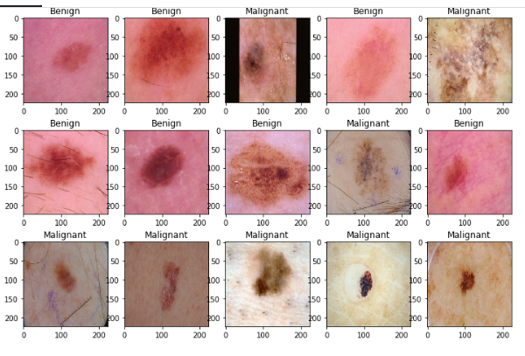

**Model training accuracy**

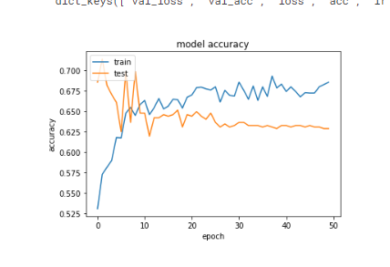

**Training and testing accuracy**

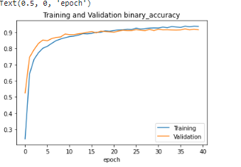

**10.advantage and disadvantages**

1. High accuracy
2. High sensitivity
3. High reliability
4. Reduced loss

**11.conclusions**

This project designed the deep learning based CNN (convolution neural network) based algorithm with consists input layer ,convolution layer ,Relu layer ,maxpooling layer for extract the features for training of images

**12.FUTURE WORK**

In future work we designed real time implementation transfer The prospects presented by the use of AI technology in the sphere of medical services should not be overlooked. AI advancements can assist in filtering through massive amounts of data to find patterns, correlations, and conduct complicated computations, activities that robots are better able to execute than people. The suggested model, which is based on the Convolution neural network V2 and LSTM approaches, showed effectiveness for skin disease categorization and detection while requiring little computing resources and effort. When tested and compared to other algorithms using real-time photographs obtained from Cagle, the result is encouraging, with effectiveness of 85.34 percent. When the background of the tumor image is reduced and the actual levels are self-explanatory and compared to the levels required to form the resulting matrix, the pixels drop. In this phase, the process affects the values of each group of beliefs (matrices, relationships and behaviors) that are considered to be inconsistent. Reliability issues and time-saving costs cannot be achieved at the same time, which occurs at the training level and is influenced by the variability of different models, which are important issues. An effective way to invade invasion invasion not used, not used. used, not used, not used. To test the need, several different trainings were used. In addition, many researchers have focused on various features in training and measurement. Because of the variability in systems across all textbooks, effective comparisons are not possible